Contractor Contact Name:  Event Name: _____________________ | Exhibiting Name: | Stand Number:  Risk Assessment
Company Name: | Today’s Date & Signature:  ______ / ______ / __________ __________________________________________________
Task / Subject:  If this Task/Subject is relevant to your activities describe what may cause harm while you are doing it | Hazard (s):  Describe any hazards with the potential to cause harm during the task or activity | Who’s at risk:  Exhibitors, Contractors, Sub-contractors, Visitors, Organisers, Venue Staff, Young/new/inexperienced staff, General public, Disabled, Lone Workers, Children, Other (specify). | Risk level  Frequent Severity Max loss & Probability  Severity – 1 low, 2, 3, 4, 5 high  Probability – 1 low, 2, 3, 4, 5 high  Risk Rating:  Severity x Probability  Example: S3 x P2 = R6 | Precautions, existing measures or Control Measures required:  ‘What are you already doing to control the risks?  What further action do you need to take to control the risks? | Comments:  Provide any additional information, clarifications, or notes relating to the risk assessment, including assumptions, limitations, or further actions required.
Working at Height
Work carried out in any place where a person could fall and injure themselves.
Example: Using a ladder to install signage above head height.

Manual Handling
Definition: Tasks involving lifting, carrying, pushing, or pulling items by hand.
Example: Lifting exhibition panels during stand build.
Slips / Trips / Falls
Definition: Hazards that may cause someone to lose balance or fall on the same level.
Example: Loose cables on the floor causing a trip hazard.
Electrical
Definition: Risks associated with electrical equipment or power sources.
Example: Using extension leads and power tools on site.
Fire
Definition: Risks that could lead to fire or fire spread.
Example: Use of electrical equipment that may overheat.
Tools
Definition: Use of hand or power tools that could cause injury if misused.
Example: Using a drill during stand construction.
PPE & Hand Sanitisation
Definition: Use of protective equipment and hygiene measures to reduce risk.
Example: Wearing gloves and providing hand sanitiser stations.
Add further information on additional pages to describe the following if relevant.
If you have these activities on your exhibition stand during the show open period, then you may be asked for a specific risk assessment and PL insurance certificate
Working Machinery

Definition: Operation of machinery that may pose risks during use.
Example: Running a demonstration machine on the stand.

Live Demonstrations

Definition: Activities performed live that may pose risks to people nearby.
Example: Product demonstration involving moving parts.

Display Vehicles

Definition: Vehicles displayed or used on the stand that may pose risks.
Example: A car displayed on the stand with restricted access.

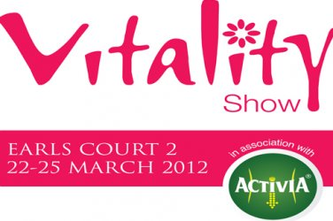

Page 2 of 2

